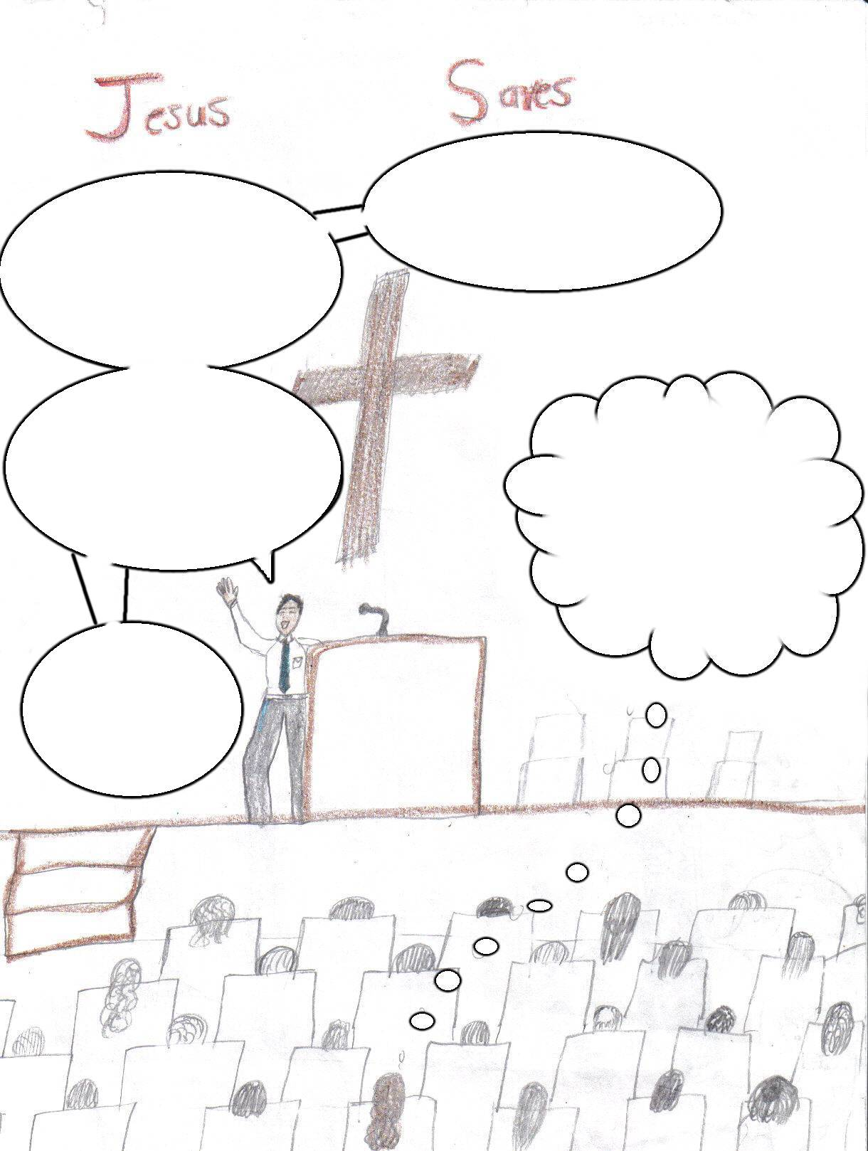
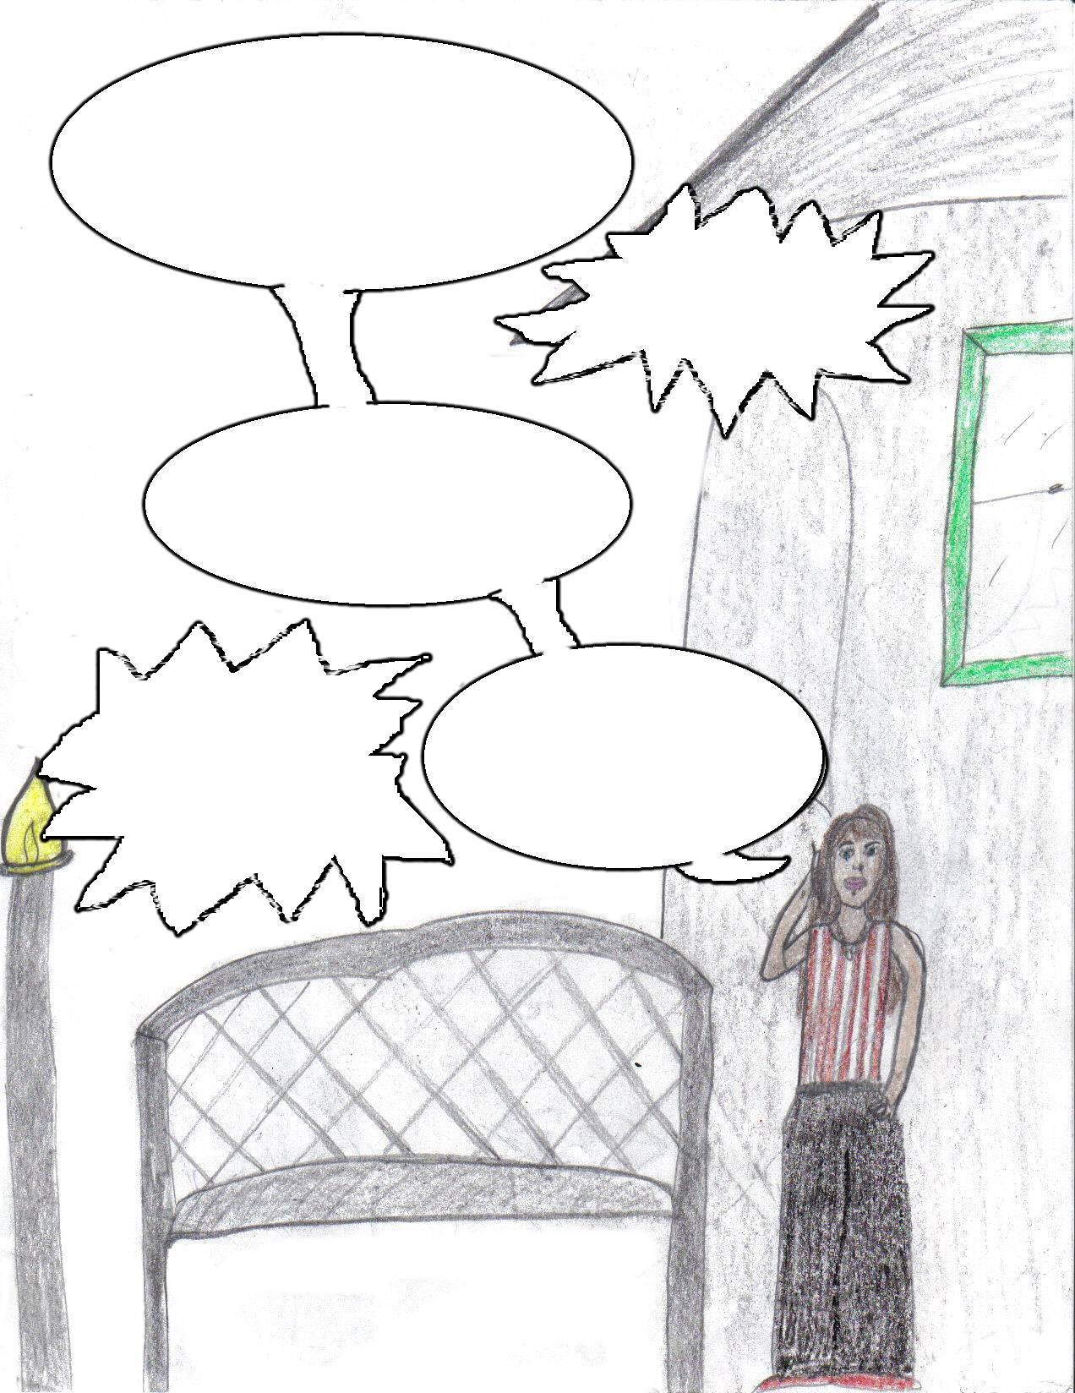


Jesus is the WAY
the TRUTH and
the LIFE.
Would you give your life to Him today?

He loves you so very much.

Your only other option is sin and Satan is the ruler of that.

Only God can give you
true peace and joy!

Jesus brings understanding.
Satan brings confusion.
Isaiah 53:6 Says “All we like sheep have astray.”
My grace is
sufficient for thee: for my strength is made perfect in weakness.
Romans 3:23 For all have sinned, and come short of the glory of God;

I’m so glad tonight. Thank you Lord for your love, kindness, and mercy. I don’t deserve it. I feel such peace!
What now I can’t get a hold of anyone; I need to talk to someone.
( Becky)
Hello Rose, how are you?
Well to tell you the
truth, I’m stuck! I’ve done everything and I’m sick of my life now. I give up!
Okay, I’ll think about it, bye





Believe
on the name of the Lord Jesus Christ and you shall be saved
Well, we
are having church services this week;
and your welcome
to come along.
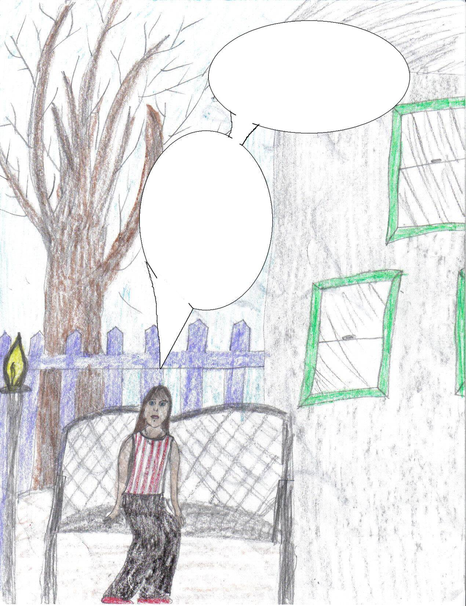
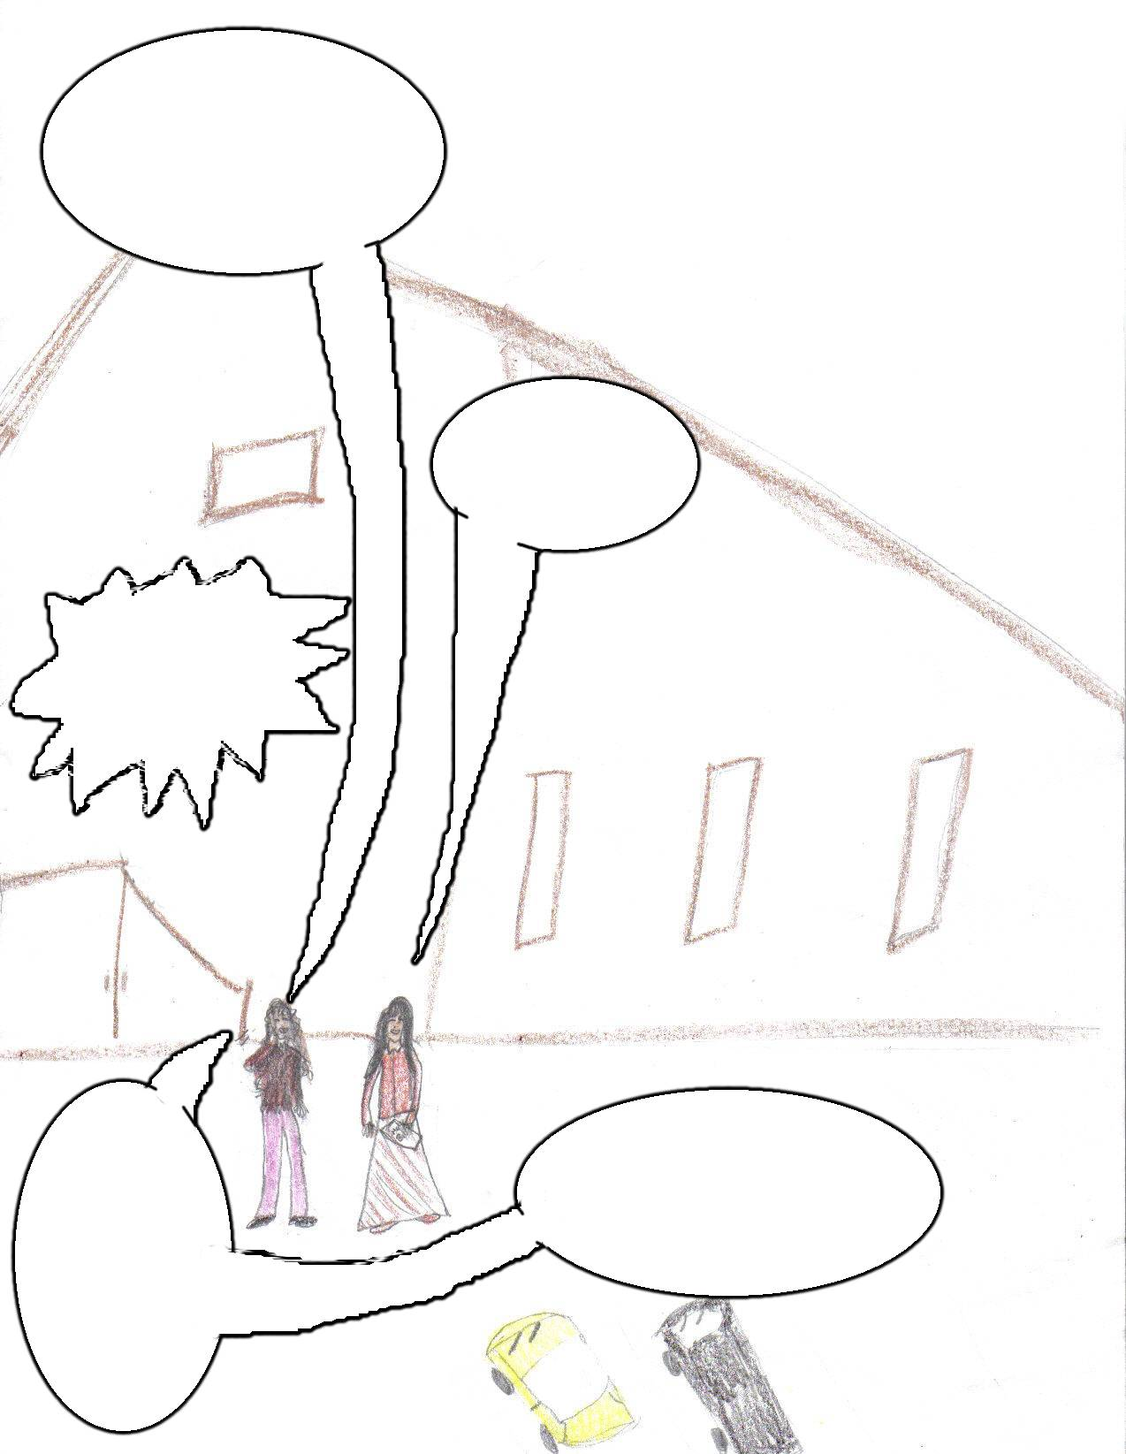
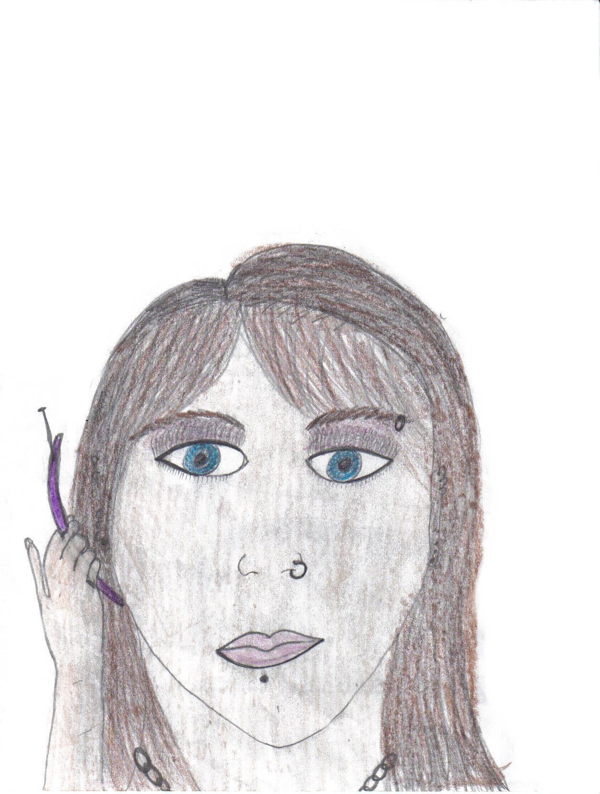
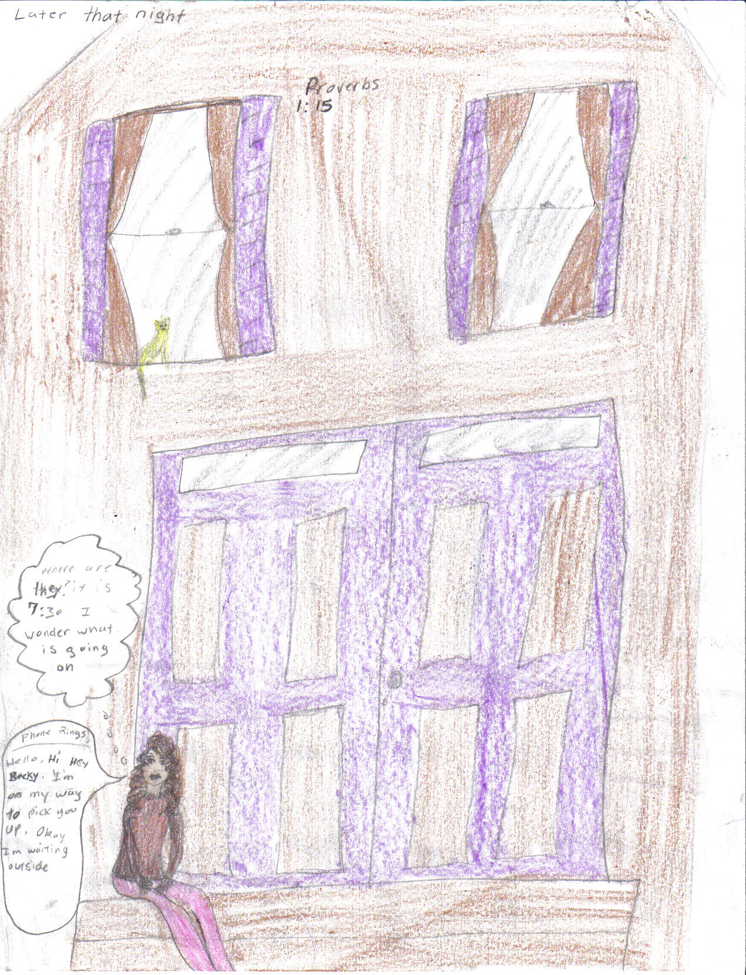
I hate my life, why am
I still here? I know God is real; but it is so hard to serve him. I can’t do anything I want to.
Then
again, I’ve
done everything already And it is all so empty, I just want to be happy. What am I doing wrong?
I’m glad you came.

Oh no!
I’m so
sorry. I will be praying for you
Romans 6:23
For the wages of sin is death, but the gift of God is eternal life through Jesus Christ our Lord.
Okay, We’ll pick
you up at seven.

Proverbs 1:15
My son, walk thou not in the way with them; refrain thy foot from their path;
Hi, this is
Ali’s Mom. Ali and her friends
all died tonight in a car accident, and they were
all drinking.
Jesus, thank you for saving my soul. That could’ve been me in that car tonight; I will live my life right, and serve the Lord.
This is what I
needed Becky. Nothing else will do. Now I know what my problem was! It was me.
Oh, my phone’s ringing.
Yeah hi Ali, I was trying to call you a few minutes ago.
Well I had plans but!!! Well ok!
Hello Rose, we
are going out tonight,
are you coming?
I’ll just
call Becky and tell her I’ll go to church next
week.
Later that night
Where is Ali? It is seven thirty. What is going on?
Okay I’m waiting outside.
Hello Rose this is
Becky. I’m on my
way to pick
you up.

